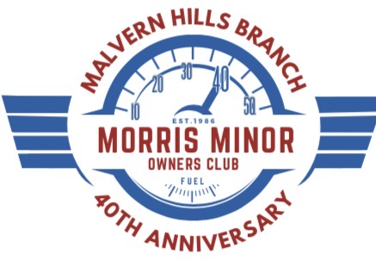

BRANCH RALLY – SUNDAY 19th JULY 2026

HARTLEBURY CASTLE, HARTLEBURY, KIDDERMINSTER DY11 7XZ

The Branch Rally this year is being held at Hartlebury Castle in celebration of our 40th Anniversary. We held our first Branch Rally at Hartlebury in 1986 and were last here in 2014.
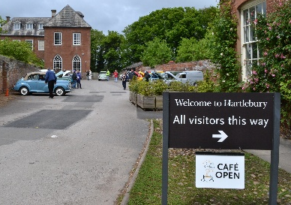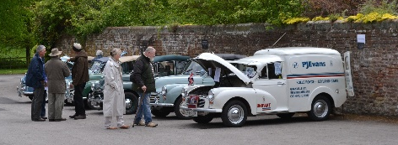
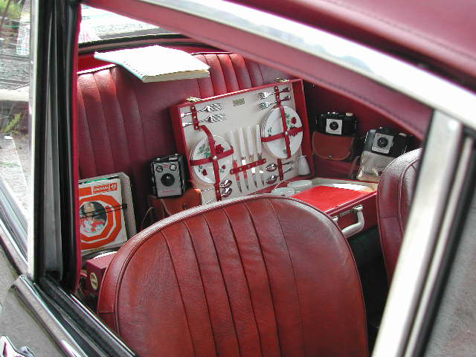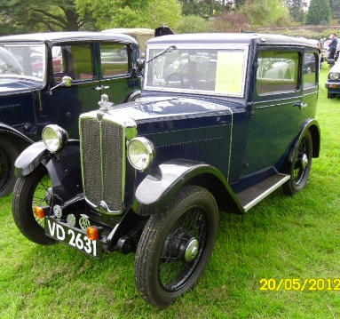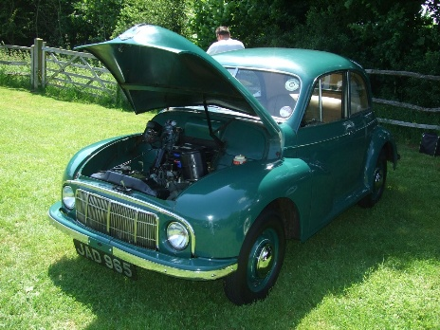
Read a bit about Hartlebury Castle and the important Rally timings on the next page, fill in the entry form below and send it with your payment of £8 (see below) to Dave Bennett by e-mail at dav4db@yahoo.co.uk or in person or at 17 Kittiwake Drive, Kidderminster DY10 4RS. Dave's telephone number is 01562 742065.

(NOTE. You can pay by cheque (payable to MMOC MH Branch) or by BACS to MMOC MH Branch, Sort Code: 52 10 23, A/C No: 11525134; use your name as reference.)

INVITATION TO MALVERN HILLS BRANCH RALLY
SUNDAY 19th JULY 2026 – HARTLEBURY CASTLE

Hartlebury Castle
Hartlebury Castle was first given to Bishop Aelhun in 855AD and was the home of the Bishops of Worcester until 2007. Three of its bishops became saints, two were burned at the stake for their faith, one became the Pope who refused Henry the VIII his divorce and another was present at the execution of Mary Queen of Scots.

The Bishop's Palace
You can admire the talking portraits, the grand State Rooms and the unique Hurd Library as you delve into the lives of the Bishops. Characters in the Castle's past, including the butler who nearly sent the Prime Minister to the tradesman's entrance and the beloved toy rabbit saved for the Bishop's granddaughter are available in the free audio guide.

Worcestershire County Museum
Explore the history of Worcestershire through fascinating museum collections including toys, costume, archaeology and agriculture. Step back to Victorian times in the schoolroom and scullery, take a tour of the 1950s in the Lavish Living exhibition and enjoy three centuries of fashion in Captivating Costume – from the extravagant frocks of the Georgians to the miniskirts of the 1960s. Whatever your interest or era, you'll find something to connect with. The Transport Gallery is closed for essential maintenance.

Why is it called a Castle?
When first owned by the Bishops of Worcester, the site was referred to as a Manor. It became a Castle officially in 1268 when Bishop Giffard was given permission to fortify the site. The fortifications remained for nearly four centuries until they were destroyed in 1648 at the end of the Civil War ensuring that it was never defendable again. When the Castle was restored in 1675 by Bishop Fleetwood, there was no longer any need for a fortified castle. More recently, the Castle became known as the Bishop's Palace, the official name given to a Bishop's residence.

Café and Shop
After you have explored the Castle and grounds, a visit to the Castle Café is the perfect way to relax. The shop offers a variety of souvenirs and gifts from local businesses.

Rally timings
The Rally is open from 9.30 am to 4 pm. If you, a member of MH Branch, wish to appear in a 40th Anniversary commemorative photograph, please park in the Courtyard between 9.30 and 10.30 am as we have to be clear of the Courtyard by 11 am; we will then re-locate to the Rally field for registration and parking. Non-members will go straight to the field. Prize-giving starts at 3 pm. The Rally entry fee is £8 per car: this includes a special 40th Anniversary commemorative memento. Come along and enjoy a fabulous Morris Minor day out!

RALLY ENTRY FORM

HARTLEBURY CASTLE - SUNDAY 19th JULY 2026

Your details (block capitals please):

Name: ……………………………………………….. MMOC No (if applicable): …….…………..

Adults: ……………….. Children: …………………

Address: .……………………………………………………………………………………………...

……………………………………………………………………… Post Code: ……………………

Telephone numbers: Home: ……………………………… Mobile: ………………………………

Your car details: Reg no: …………………….… Year: ……….…… Body: ….…….………….....

Judging Category (please tick):
Model: Engine size (cc):

MM/Series II: …………….. …………….
2-Door Saloon: …………….. …………….
4-Door Saloon: …………….. …………….
Convertible: …………….. …………….
Traveller: …………….. …………….
Commercial: …………….. …………….
Customised/Modified: …………….. …………….
Open (non-Morris Minor): …………….. …………….

Send or give this page with your remittance to Dave Bennett by e-mail at dav4db@yahoo.co.uk or at 17 Kittiwake Drive, Kidderminster DY10 4RS. Dave's telephone number is 01562 742065.

NOTE. You can pay by cheque (payable to MMOC MH Branch) or by BACS to MMOC MH Branch, Sort Code: 52 10 23, A/C No: 11525134; use your name as reference.

